Neil Shet
CIS 4374 Information Systems Project Management

Homework 1
Initial Kickoff (Version 1.0)

Vision and Scope
Project Acquisition
$oftware Corp. identified an opportunity to improve urban parking management through a digital platform that provides real-time parking information. The organization selected the Smart Parking Platform project because drivers waste significant time searching for parking spaces, while parking operators often lack efficient tools for monitoring occupancy and managing reservations. The project aims to improve the parking experience for users while increasing operational efficiency for parking facility operators.
Vision Statement
The Smart Parking Platform will provide drivers with a convenient method to locate, reserve, and pay for parking spaces through a web and mobile application. The platform will reduce time spent searching for parking and improve parking facility utilization.
Project Scope
The project includes:
- User account registration and login
- Parking space search
- Real-time parking availability
- Parking reservations
- Digital payment processing
- Navigation assistance
- Notifications and alerts
- Administrative dashboard
- Occupancy reporting and analytics
The project excludes:
- Physical parking garage construction
- Hardware installation within parking facilities
- Vehicle maintenance services
Competitive Analysis
ParkMobile
Strengths:
- Widely used
- Simple mobile payments
- Real-time parking sessions
Weaknesses:
- Limited reservation availability in some areas
- Depends on participating cities
ParkWhiz
Strengths:
- Event parking reservations
- User-friendly interface
Weaknesses:
- Less focus on real-time occupancy data
SpotHero
Strengths:
- Advanced reservations
- Large network of garages
- Price comparisons
Weaknesses:
- Availability varies by city

Opportunity for Differentiation
Our Smart Parking Platform will differentiate itself through:
- Real-time occupancy tracking
- AI-based parking recommendations
- Predictive availability forecasting
- Dynamic pricing suggestions
- Unified mobile and web experience
Stakeholders
Stakeholder | Interest
Drivers | Find parking quickly
Parking Operators | Increase utilization
City Transportation Departments | Reduce congestion
System Administrators | System maintenance
Finance Personnel | Payment processing
Payment Providers | Payment integration

Initial Use Cases
Use Case 1: Register Account
Actor: Driver
Goal: Create an account.
Basic Flow:
- User enters information.
- System validates information.
- Account is created.
Use Case 2: Search for Parking
Actor: Driver
Goal: Find available parking.
Basic Flow:
- User enters destination.
- System displays nearby garages.
- User views availability.
Use Case 3: Reserve Parking Spot
Actor: Driver
Goal: Reserve a parking spot.
Use Case 4: Make Payment
Actor: Driver
Goal: Pay for reservation.
Use Case 5: View Occupancy Dashboard
Actor: Parking Operator
Goal: Monitor garage utilization.
Initial Requirements
Functional Requirements
FR-1: The system shall allow user registration.
FR-2: The system shall display real-time parking availability.
FR-3: The system shall allow parking reservations.
FR-4: The system shall process online payments.
FR-5: The system shall generate occupancy reports.
Nonfunctional Requirements
NFR-1: System uptime must be 99%.
NFR-2: Payment transactions must be encrypted.
NFR-3: Mobile pages should load within 3 seconds.
NFR-4: Platform must support at least 10,000 users.

Homework 2
Deliverables (WBS/Draft Timeline) (Version 2.0)

Work Breakdown Structure (WBS)
1.0 Authentication System
1.1 User Registration
- 1.1.1 Registration Form
- 1.1.2 Account Validation
- 1.1.3 Account Creation
1.2 User Login
- 1.2.1 Login Screen
- 1.2.2 Credential Verification
- 1.2.3 Session Management

2.0 Parking Search and Reservation
2.1 Parking Search
- 2.1.1 Location Search
- 2.1.2 Map Display
- 2.1.3 Availability Display
2.2 Parking Reservation
- 2.2.1 Create Reservation
- 2.2.2 Modify Reservation
- 2.2.3 Cancel Reservation

3.0 Payment Processing
3.1 Payment Integration
- 3.1.1 Payment Gateway Setup
- 3.1.2 Secure Transaction Processing
- 3.1.3 Receipt Generation
3.2 Financial Records
- 3.2.1 Payment History
- 3.2.2 Billing Reports

4.0 Administrative Dashboard
4.1 Parking Operator Management
- 4.1.1 Garage Management
- 4.1.2 Space Availability Updates
- 4.1.3 User Management
4.2 Reporting and Analytics
- 4.2.1 Occupancy Reports
- 4.2.2 Revenue Reports
- 4.2.3 Usage Analytics

5.0 Notifications and Navigation
5.1 Notifications
- 5.1.1 Reservation Confirmation
- 5.1.2 Payment Confirmation
- 5.1.3 Parking Reminders
5.2 Navigation Services
- 5.2.1 Mapping Integration
- 5.2.2 Route Guidance
- 5.2.3 Destination Assistance

Project Schedule

Task ID | Task | Duration
1 | Requirements Analysis | 1 Week
2 | System Design | 1 Week
3 | Authentication Development | 1 Week
4 | Parking Search Development | 1 Week
5 | Reservation System Development | 1 Week
6 | Payment Integration | 1 Week
7 | Administrative Dashboard | 1 Week
8 | Notifications & Navigation | 1 Week
9 | Testing & Quality Assurance | 1 Week
10 | Final Project Review | 1 Week

Dependencies
- System Design begins after Requirements Analysis.
- Authentication Development begins after System Design.
- Parking Search Development begins after Authentication Development.
- Reservation System Development begins after Parking Search Development.
- Payment Integration begins after Reservation System Development.
- Administrative Dashboard begins after Payment Integration.
- Notifications & Navigation begins after Administrative Dashboard.
- Testing & Quality Assurance begins after all development activities are complete.
- Final Project Review begins after Testing & Quality Assurance.

Gantt Chart (Draft)
Task | W1 | W2 | W3 | W4 | W5 | W6 | W7 | W8 | W9 | W10
Requirements Analysis | X
System Design |  | X
Authentication Development |  |  | X
Parking Search Development |  |  |  | X
Reservation System Development |  |  |  |  | X
Payment Integration |  |  |  |  |  | X
Administrative Dashboard |  |  |  |  |  |  | X
Notifications & Navigation |  |  |  |  |  |  |  | X
Testing & QA |  |  |  |  |  |  |  |  | X
Final Review |  |  |  |  |  |  |  |  |  | X

Project Milestones
Milestone 1: Requirements Approved (End of Week 1)
Milestone 2: System Design Completed (End of Week 2)
Milestone 3: Core User Features Completed (End of Week 5)
Milestone 4: Payment Processing Completed (End of Week 6)
Milestone 5: System Testing Completed (End of Week 9)
Milestone 6: Final Project Submission (End of Week 10)

Homework 3
Product Backlog using Trello (Version 3.0)
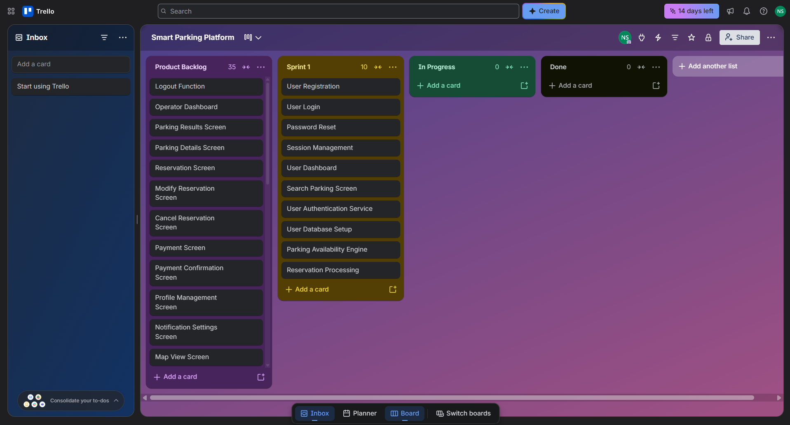

Sprint 1 Status Update
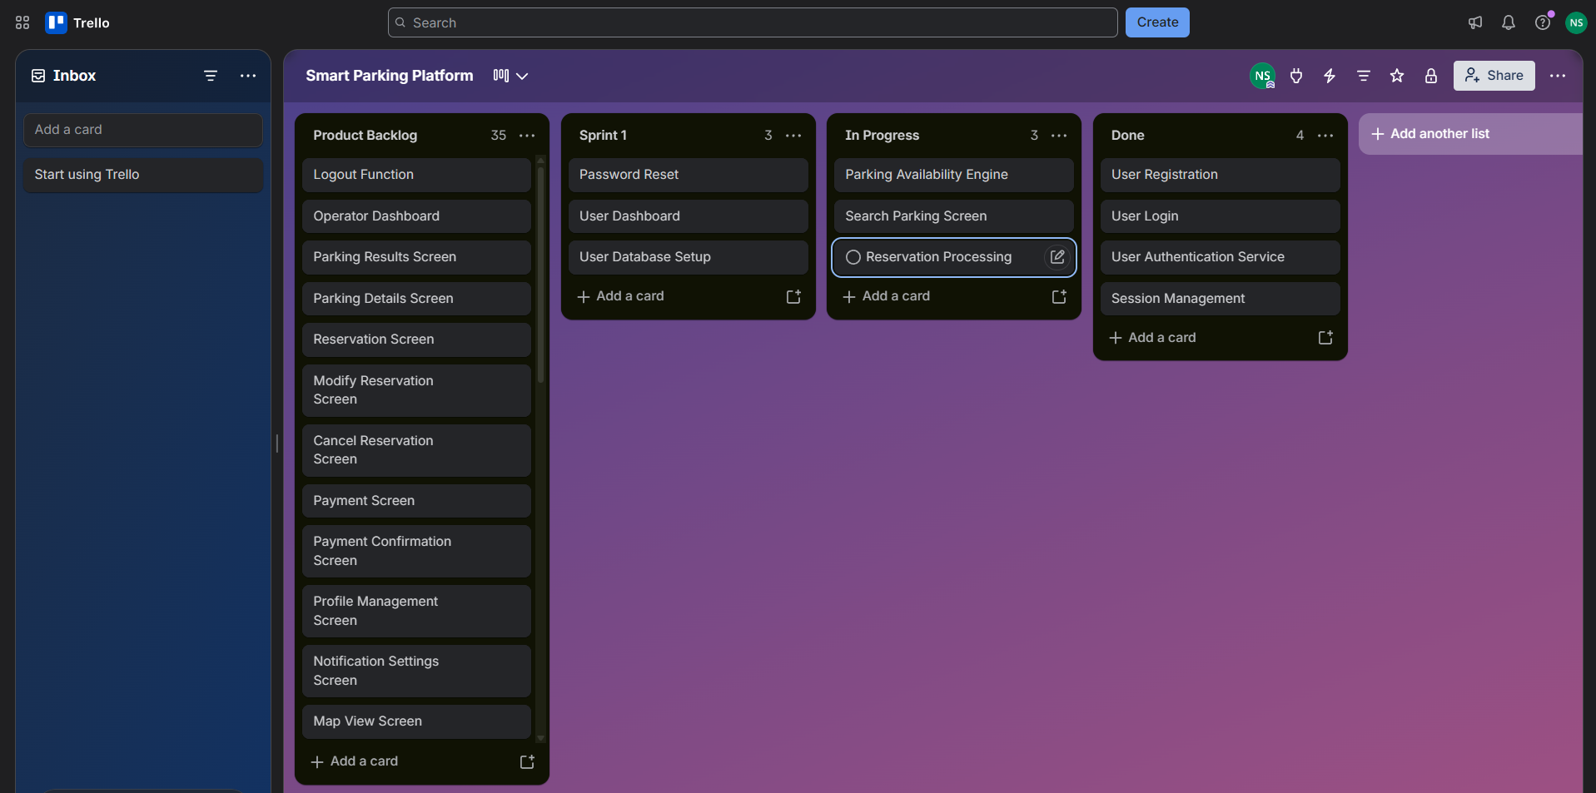

Homework 4
Risk Management and Communication Plan (Version 4.0)

Risk Identification
Technical Risks
- Payment gateway integration may fail or experience compatibility issues.
- Real-time parking availability data may be inaccurate or delayed.
- Security vulnerabilities could expose user information.
- System performance may degrade under high user traffic.
Schedule Risks
- Development tasks may take longer than estimated.
- Testing may identify major defects requiring rework.
- Requirement changes could delay project completion.
- Dependencies between project tasks may create bottlenecks.
Financial Risks
- Development costs may exceed the planned budget.
- Third-party service fees may increase unexpectedly.
- Additional software or licensing costs may be required.
- Payment processing expenses could be higher than anticipated.
People Risks
- Team members may become unavailable during the project.
- Communication breakdowns could delay progress.
- Stakeholder feedback may not be received on time.
- Team members may lack expertise in certain project areas.

ID | Risk Description | Probability | Impact | Owner | Response Strategy | Status
R1 | Payment gateway integration failure | Medium | High | Development Team | Conduct early integration testing | Monitoring
R2 | Inaccurate parking availability data | Medium | High | Technical Lead | Implement data validation checks | Open
R3 | Security vulnerabilities | Medium | High | Security Team | Perform regular security testing | Open
R4 | System performance issues | Medium | Medium | Development Team | Conduct performance testing | Open
R5 | Schedule delays | Medium | High | Project Manager | Monitor milestones weekly | Monitoring
R6 | Requirement changes | Medium | Medium | Project Manager | Use change control procedures | Open
R7 | Budget overruns | Low | High | Finance Team | Review project budget regularly | Open
R8 | Increased third-party service costs | Low | Medium | Finance Team | Monitor vendor contracts | Open
R9 | Team member unavailability | Low | Medium | Project Manager | Cross-train team members | Open
R10 | Delayed stakeholder feedback | Medium | Medium | Project Manager | Schedule recurring review meetings | Monitoring

Several project risks continue to be monitored. No high-priority risks have materialized at this stage of the project.
Communication Plan
Meeting Cadence
Team/Stakeholder Group | Frequency | Communication Method | Purpose
Project Team | Weekly | Microsoft Teams | Project status updates
Development Team | Twice Weekly | Teams/Trello | Progress tracking and issue resolution
Testing Team | Weekly | Microsoft Teams | Testing and defect reviews
Stakeholders | Bi-Weekly | Teams/Email | Project updates and feedback
Finance Team | Monthly | Email/Meeting | Budget and cost review

Communication Status Update
- Weekly project meetings are being conducted as scheduled.
- Sprint progress is tracked through Trello.
- Stakeholder communication remains on schedule.
Reporting Methods
- Weekly project status reports
- Trello board updates
- Sprint review meetings
- Email progress summaries
- Milestone completion reports
- Final project presentation

Homework 5
Roles & Resources, Resource & Cost Plan, and RACI Matrix (Version 5.0)

Roles & Resources
The Smart Parking Platform project requires a cross-functional team responsible for planning, designing, developing, testing, and managing the system.
Role | Team Member | Skill Level | Allocation
Project Manager | Sarah Johnson | Senior | 20%
Business Analyst | Michael Lee | Intermediate | 15%
Developer 1 | Alex Carter | Senior | 40%
Developer 2 | Emily Davis | Intermediate | 40%
QA Tester | Daniel Brown | Intermediate | 20%
UI/UX Designer | Jessica Wilson | Intermediate | 15%
Resource Assumptions
- The Project Manager oversees scheduling, risk management, and communication.
- The Business Analyst gathers and validates requirements.
- Developers are responsible for application development and integration.
- The QA Tester performs testing and quality assurance activities.
- The UI/UX Designer creates user-friendly interfaces for both drivers and parking operators.
Resource & Cost Plan
Bottom-Up Cost Estimate
Role | Estimated Hours | Hourly Rate | Cost
Project Manager | 80 | $50 | $4,000
Business Analyst | 60 | $40 | $2,400
Developer 1 | 160 | $45 | $7,200
Developer 2 | 160 | $45 | $7,200
QA Tester | 80 | $35 | $2,800
UI/UX Designer | 40 | $40 | $1,600

- Labor Cost Total: $25,200

Resource Utilization Update
- The project team continues to operate within the planned resource allocations. No additional staffing or budget adjustments are required at this time.
- This is a very normal project update.

Additional Project Expenses
Expense Item | Cost
Cloud Hosting Services | $600
Software Licenses | $500
Third-Party API Integration | $400
Contingency Reserve (10%) | $2,670

- Total Estimated Project Cost: $29,370
Budgeted Monthly Cash Flow
Month | Labor Cost | Infrastructure | Tools/APIs | Total Cost
Month 1 | $8,400 | $200 | $250 | $8,850
Month 2 | $8,400 | $200 | $250 | $8,850
Month 3 | $8,400 | $200 | $400 | $9,000

- Total Budget: $26,700
RACI Matrix
R = Responsible
A = Accountable
C = Consulted
I = Informed

Project Activity | PM | BA | DEV | QA | UI/UX
Requirements Gathering | A | R | I | I | C
System Design | A | C | R | I | C
User Interface Design | I | C | C | I | R/A
Authentication Development | C | I | R/A | I | I
Parking Search Development | C | I | R/A | I | C
Reservation System Development | C | I | R/A | I | I
Payment Integration | C | I | R/A | I | I
Dashboard Development | C | I | R/A | I | C
Testing & Quality Assurance | I | I | C | R/A | I
Deployment | A | I | R | C | I
Final Project Review | A | C | C | C | I

Homework 7
Stakeholder Analysis (Power-Interest Grid)
The Smart Parking Platform involves several stakeholders with different levels of influence and interest in the project. Using a Power-Interest Grid helps determine how each stakeholder should be managed throughout the project.
High Power / High Interest (Manage Closely) | High Power / Low Interest (Keep Satisfied)
Parking Operators | Finance Personnel
City Transportation Departments | Payment Providers

Low Power / High Interest (Keep Informed) | Low Power / Low Interest (Monitor)
Drivers | General Public
System Administrators | Future Parking Facility Partners

Stakeholder Analysis Summary
Parking Operators and City Transportation Departments are the most important stakeholders because they have a strong influence on the success of the project and will be actively involved in using the system. Drivers and System Administrators have a high interest in the project but less decision-making authority. Finance Personnel and Payment Providers have influence over project operations, but they are less involved in the day-to-day development activities.
Project Charter
Project Name
Smart Parking Platform
Project Purpose
The purpose of the Smart Parking Platform is to help drivers find available parking more efficiently through a web and mobile application. The system will allow users to search for parking spaces, make reservations, complete secure payments, and receive navigation assistance. The project is intended to improve convenience for drivers while helping parking operators better utilize available parking spaces.
Project Objectives
- Provide real-time parking availability information.
- Allow users to reserve parking spaces.
- Support secure online payments.
- Reduce the time drivers spend searching for parking.
- Provide operators with reporting and analytics tools.
Project Scope
In Scope
- User registration and login
- Parking space search
- Parking reservations
- Payment processing
- Notifications and alerts
- Administrative dashboard
- Reporting and analytics
Out of Scope
- Construction of new parking facilities
- Hardware installation in parking garages
- Vehicle maintenance services
Key Stakeholders
- Drivers
- Parking Operators
- City Transportation Departments
- System Administrators
- Finance Personnel
- Payment Providers
Estimated Budget
$29,370
Project Success Criteria
The project will be considered successful if users can successfully search for parking, reserve spaces, make payments, and if parking operators can effectively manage occupancy and reporting through the platform.

Team Charter
Team Name
Smart Parking Development Team
Team Mission
Our mission is to plan and manage the development of a Smart Parking Platform that provides a simple, secure, and efficient parking experience for both drivers and parking operators.
Team Members
Team Member | Role
Sarah Johnson | Project Manager
Michael Lee | Business Analyst
Alex Carter | Developer
Emily Davis | Developer
Daniel Brown | QA Tester
Jessica Wilson | UI/UX Designer

Team Expectations
- Attend project meetings regularly.
- Complete assigned tasks by agreed deadlines.
- Communicate project issues as soon as possible.
- Support other team members when needed.
- Maintain professionalism and respect during collaboration.
Communication Methods
- Microsoft Teams meetings
- Trello board updates
- Email communication
- Weekly status reviews
Conflict Resolution
If disagreements occur, team members will first discuss the issue together and attempt to find a solution. If the issue cannot be resolved, the Project Manager will review the situation and make a final decision.

Copilot Office 365 provided by UH was utilized as an analytical tool to assist in organizing data. All final analytical conclusions, evidence verification, source selection, and narrative text were critically reviewed, edited, and approved by the student author.

References
ParkMobile parking app: Find & Pay For Parking: On-Street & Reservation. ParkMobile. (n.d.). https://parkmobile.io/
Find and book parking anywhere. ParkWhiz. (n.d.). https://www.parkwhiz.com/
Get everywhere easier: Reserve parking and save. SpotHero. (n.d.). https://spothero.com/

